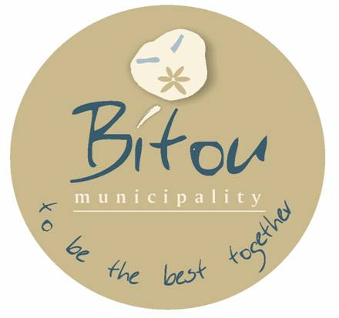

**DR. RONALD RALPH LINKS**

**UMPHATHI KAMASIPALA OBAMBELEYO**

Umasipala Wasekuhlaleni WaseBitou

Private Bag X1002

PLETTENBERG BAY

6600

**Inani Lesaziso sikaMasipala: 107/2024**

**UMASIPALA WASEBITOU (WC047)**

**INANI LESAZISO: 107/2024.**

**UHLAHLO LWABIWO-MALI KUNYE NEMIRHUMO**

**KA-2024/2025 KWAKUNYE**

**NEDRAFTI EVUNYIWEYO YESICWANGCISO SOPHUHLISO ESIHLANGANISIWEYO (IDP): 2024/2025**

Isaziso sinikezelwa ngale ndlela ngokwesiqendu 21 soMthetho woRhulumente weNgingqi: weNkqubo kaMasipala, ka-2000, iCandelo 22 loMthetho woLawulo lweMali kaMasipala, ka-2003, kunye neCandelo 127(5) loMthetho woRhulumente weNgingqi: uLawulo lweMali kaMasipala, ka-2003 (uMthetho 56 ka-2003) ofundwa kunye neCandelo 21A loMthetho woRhulumente weNgingqi: iiNkqubo zikaMasipala, 2000 (uMthetho 32 ka-2000) ukuba iDrafti ye-IDP 2024/2025, uHlahlo-lwabiwo-mali oluQulunqiweyo kunye neeTariffs 2024/2025 zikaMasipala weNgingqi waseBitou ziyafumaneka kwi-publi jikelele kunye nemibutho yokumelwa kunye nezimvo.

La maxwebhu akhankanywe ngasentla afumaneka ukuze ahlolwe kwii-ofisi zikaMasipala nakumathala eencwadi aboniswe ngezantsi: IiOfisi eziPhambili: 4 Sewell Street, PLETTENBERG BAY, Tel: 044 501 3000 (Mnu Felix Martin Lotter, iGosa eliyiNtloko lezeMali); Ii-Ofisi ze-IDP: 58 Mellviles Corner, PLETTENBERG BAY, Tel: 044 501 3198 (uMnu Thembinkosi Henge, uMphathi we-IDP), iofisi yaseQolweni, iofisi yaseGreen Valley. Iilayibrari: Idolophu (Mellville's Corner), Kwanokuthula, Green Valley, Kranshoek, Kurland, Central (New Horizons)

I-2024 / 2025 Draft IDP, Draft 2024 / 2025Budget kunye neTariffs nazo ziyafumaneka kwiwebhusayithi kaMasipala waseBitou: www.bitou.gov.za

Amagqabantshintshi okanye imiboniso malunga namaxwebhu akhankanywe ngasentla mayifike kwi-ofisi yoMphathi kaMasipala ngomhla okanye ngaphambi kwe-18 Meyi 2024.

Ukuphucula inxaxheba yoluntu kunye nokufumana igalelo elinentsingiselo, iBhunga likaMasipala waseBitou lagqiba ekubeni liququzelele iintlanganiso zikawonke-wonke zokubonisana ze-IDP / Budget njengoko kucwangcisiwe ngezantsi. Injongo yezi ntlanganiso kukunika uluntu ithuba lokunika igalelo kwidrafti ye-IDP/Budget.

Injongo: I-Presentation Draft Budget yonyaka we-2024/2025financial.

|  |  |  |  |
| --- | --- | --- | --- |
| **WARD** | **VENUE** | **DATE** | **TIME** |
| WARD 1 | KURLAND COMMUNITY HALL | 09/04/2024 | 18:00PM |
| WARD 1 | WITTEDRIFT COMMUNITY HALL | 16/04/2024 | 18:00PM |
| WARD 2 | PIESANG HALL | 30/04/2024 | 17:30PM |
| WARD 3 | BICYCLE SHED | 11/04/2024 | 18:00PM |
| WARD 4 | NEW HORIZONS COMMUNITY HALL | 10/04/2024 | 18:00PM |
| WARD 5 | KWANOKUTHULA COMM HALL | 24/04/2024 | 18:00PM |
| WARD 6 | KWANOKUTHULA COMM HALL | 23/04/2024 | 18:00 PM |
| WARD 7 | KRANSHOEK | 17/04/2024 | 18:00PM |
| WARD 7 | HARKERVILLE | 18/04/2024 | 18:00PM |

Ngolwazi oluthe kratya okanye ukubhukisha nceda uqhagamshelane ne-ofisi ye-IDP ku-044 501 3198 okanye uthumele i-imeyile ku-thenge@plett.gov.za cc tnguza@plett.gov.za

**DR. DONALD RALPH LINKS**

**UMPHATHI KAMASIPALA OBAMBELEYO**

**UMASIPALA WASEKUHLALENI WASEBITOU**